Longcross DC Model issues

ANCILLARY BLOCK.

1. Escape stair showing through roof. Ancillary block.  
   Parapet wall drops

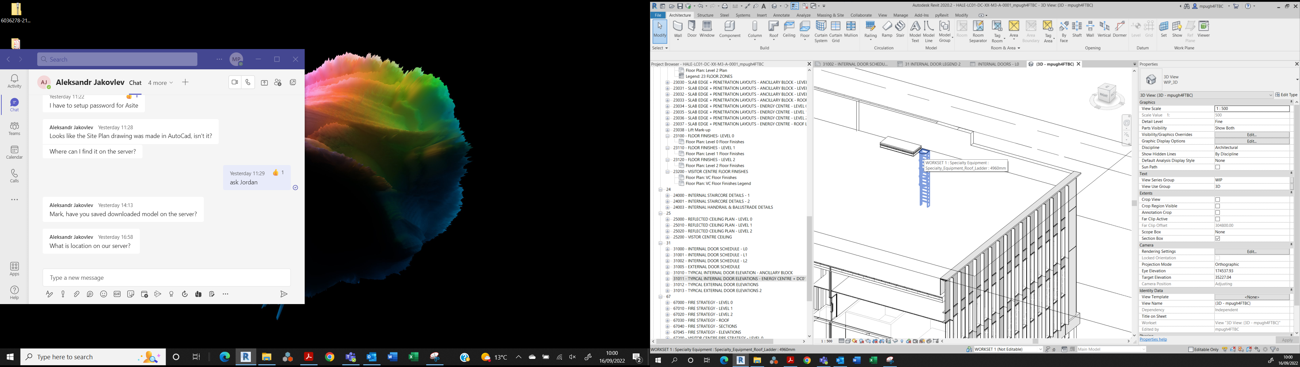

Birds eye views

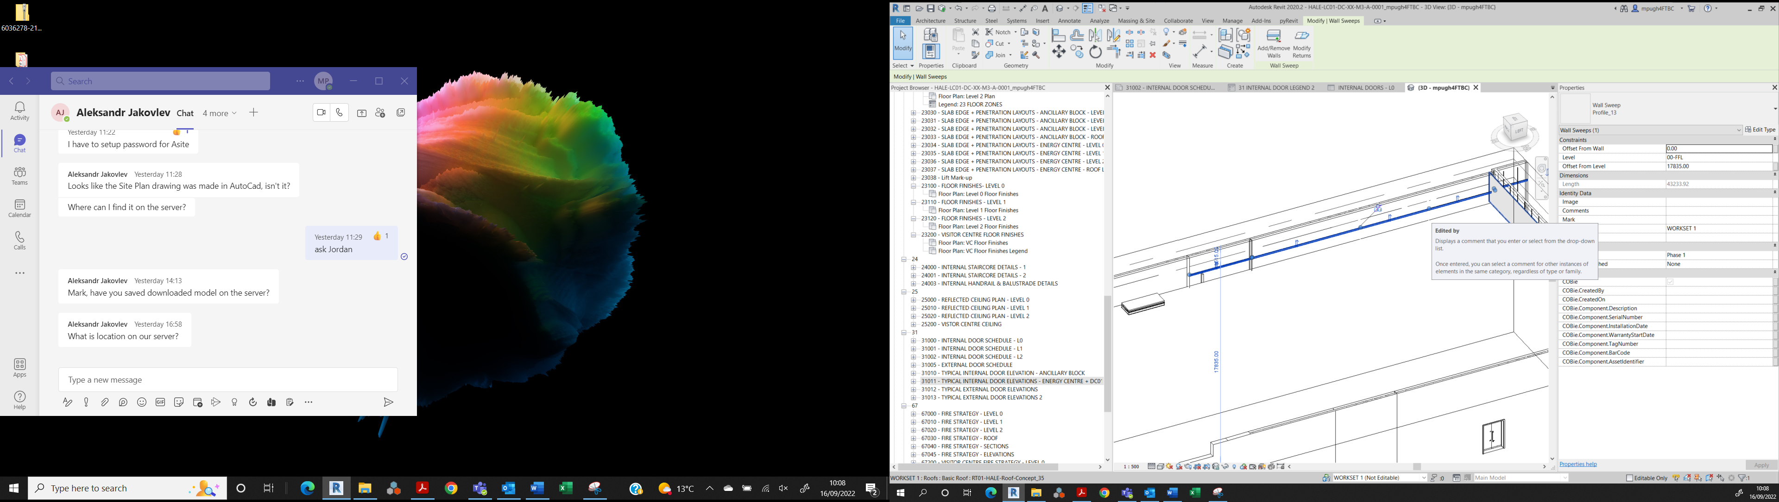 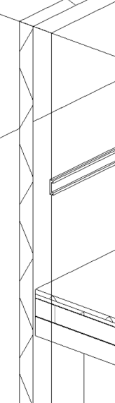

Larger 3D

Wall sweep Profile 13 above Roof

Some Internal Door heads above ceiling?   
L1 shown below:

L2 Same issue

Double floor around Lift Shafts at L0

Also Double wall.

No Door shown on Passenger Lift door on second floor

ENERGY CENTRE.

Structural Bracing currently clashes with plant…

S. Eng to Relocate to adjacent Bay against Partition.

Stair 02 (Energy Centre)  
Adjacent to lift shaft, access up to roof level.

Lift pit to align with shaft.

Internal Partition crashes though Lobby

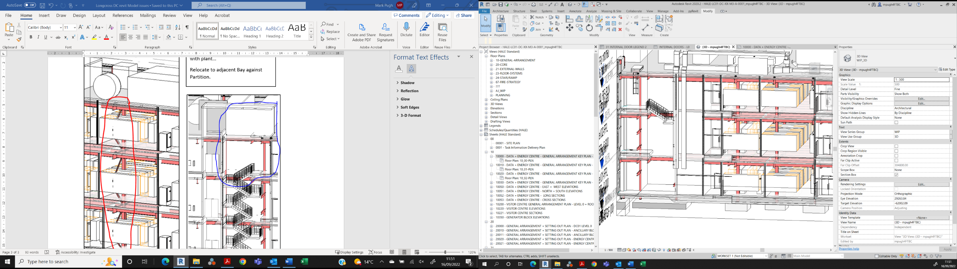

Stair 02 (Energy Centre)  
should go up to roof level.

Stair 01 (energy Centre)

Stops at Level 2 with Ladder ‘escape only’ from roof level.

Lift pit to align with shaft.